Notes on JOE data
And JOE data processing

1. Data Overview

1.1 Data transformations
The downloaded JOE data comes in wide format, with approximately 400 columns. Furthermore, non-identifier columns contained multiple encoded variables (i.e., “fe_any_w2_y1”). It was very hard to work with data like this, so the data was pivoted into long form, and columns were de-multiplexed into multiple columns, ensuring that the data was in tidy format (each column is exactly one variable, each variable is represented by exactly one column; each row is exactly one observation, each observation is represented by exactly one row). The resulting data frame contains 13 columns:
- fips (numeric)
- cohort_year (numeric)
- rural (numeric dummy)
- sex (numeric dummy)
- race (numeric dummy)
- age_group (numeric dummy)
- off_type (numeric dummy)
- repeat_contact (numeric dummy)
- is_count (TRUE/FALSE boolean)
- event_type (character)
- variable_name (character)
- years_post (numeric)
- value (numeric)

1.2 Data dimensionality
There are six dimensions to the JOE data.
- Time (cohort_year)
- County (fips)
- Demographic (sex, race, age_group, off_type, repeat_contact)
- Criminal event type (event_type)
- Outcome variable (variable_name)
- Outlook year (years_post)
So for each year, for each county, for each demographic group for each criminal event type, for each outcome statistic, for each outlook year, there is a rate and a count. A complete combination of the six dimensions is referred to as an outcome statistic.

2. Working with Proportions

  - Averaging Proportions
The data, by default, gives a proportion and the denominator of the proportion for every outcome statistic.
proportion
denominator

These two rows represent the same outcome statistic (combination of the six dimensions). In most cases, multiplying these two values gives you the numerator of the proportion.

When we want to take an average of multiple proportions, we first must decompose the proportions, meaning we must get back to the numerators and denominators. Then, we sum up all the numerators and divide by the sum of all the denominators. To achieve this, we create an additional column called “value_decomposed”.

Simply, to assign a value to “value_decomposed”, we check if the number in the “value” column contains a rate (is_count == FALSE). If it does, we multiply the rate by the number immediately below it (the denominator). Otherwise, we just copy over the denominator.
0.52 * 220

220
Once this is done, we can sum up the numerators:
sum(value_decomposed[seq(1, n(), by = 2)], na.rm = T)
and divide by the sum of the denominators:
sum(value_decomposed[seq(2, n(), by = 2)], na.rm = T)
Essentially, we are taking advantage of the fact that the rows are always alternating between the numerator and denominator, so we can just sum every other row, starting at row 1 for the numerator and at row 2 for the denominator.
There are two special cases where this simple approach does not work.
Special case 1: working with criminal rates.
When variable_name is “rate”, the outcome statistic is a per-capita measure of the corresponding event_type, displayed in units of per-100,000.
Denominator
Proportion

In the above example rows, to arrive at the numerator of the outcome statistic (number of felony defendants), we would first have to divide the denominator by 100,000. After that we proceed as discussed above. (102,000 / 100,000) * (628) = number of felony defendants.
Special case 2: working with wage rates.
When variable_name is “w2_wages”, the outcome statistic is a measure of average yearly income for the entire criminal cohort (regardless of whether they were employed). This includes individuals who had no income. It is essentially a measure of average yearly earnings with a lot of zeros in the numerator. For our research, we are interested in the average yearly earnings of the employed individuals. To achieve this, we create an additional column called “value_employed”.

To assign a value to “value_employed”, we take the following steps:
- If the variable_name is “w2_wages” and the current row is a rate (is_count == FALSE):
  - We take the numerator (value_decomposed), and divide it by the denominator multiplied by the value cell for variable_name “any_w2” (which is the employment rate), which must be exactly 4 rows above.

- If the variable_name is “w2_wages” and the current row is not a rate (is_count == TRUE):
  - We take the denominator (value_decomposed), and multiply it by the value cell for variable_name “any_w2” (which is the employment rate), which must be exactly 5 rows above.
- Otherwise, NA.
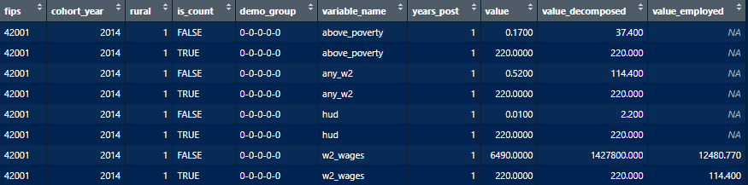
1428700 / (220 * 0.52)
220 * 0.52

Now we can sum up the numerators:
sum(value_decomposed[seq(1, n(), by = 2)], na.rm = T)
and divide by the sum of adjusted denominators:
sum(value_employed[seq(0, n(), by = 2)], na.rm = T)

Essentially, we are modifying the denominator by multiplying it by the corresponding employment rate (any_w2). Thus, as in our example here, the denominator gets cut in half, resulting in a larger average yearly earnings statistic. This statistic now represents the average yearly earnings for all employed individuals. Similarly, the denominator represents the count of individuals with employment history.

3. Cohort Years
3.1 Entry & Exit
For Economic and Health outcome statistics: the cohort year (cohort_year) is based on the individuals’ exit from the judicial system. We can think of “charges filed” as their entry into the judicial system, and “charges disposed” as their exit year. There is one bit of nuance to this, which is that per-capita rates of criminal events are recorded for the year in which they were charged. See figure below.

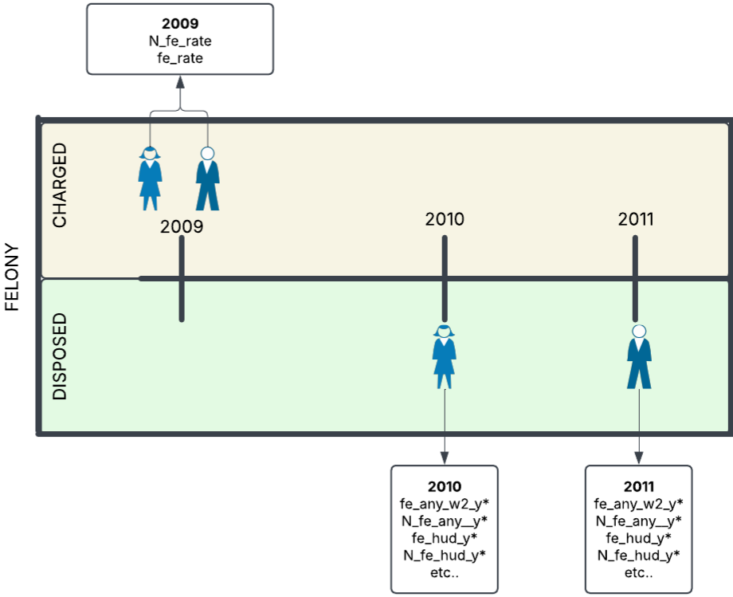

Furthermore, for “felony” and “misdemeanor” event types (event_type), the cohort size for charges filed is approximated as equal to the cohort size for charges disposed.
An extract from the technical documentation:
“…for felony and misdemeanor cohorts, outcome statistic cohort years are based on charge disposition date, but the reported cohort sizes are based on charge filing date. Incarceration socioeconomic outcome statistics as well as their cohort sizes are based on incarceration exit. Parole and probation socioeconomic outcome statistics as well as their cohort sizes are based on parole and probation entry dates”
3.2 Two-Year Windows
When looking at outcome statistics that include at least one demographic breakdown, the reported proportions and denominators represent a two-year window rather than a single year. For instance, what might be labeled as the 2009 employment rate for white individuals actually encompasses data from both 2010 and 2011 combined. There two-year windows do not overlap. The next windows are 2012+2013, 2014+2015 and so on.
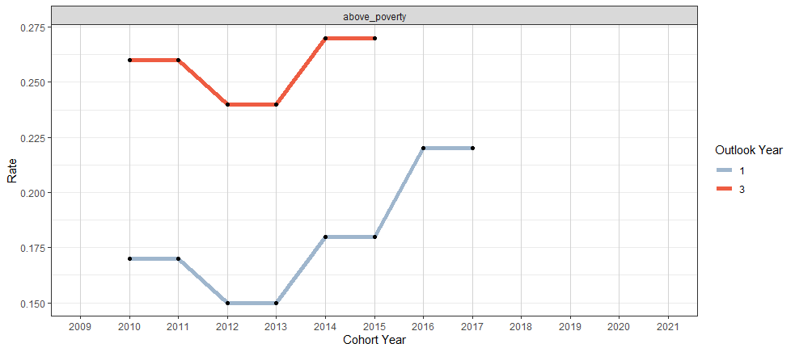
These are the two-year windows for the above poverty (above_poverty) rate statistic for white felons, at one and three years after disposition.
For this example, we are looking at the 2010 cohort for white felons (which encompasses 2011 as well). For the one-year outlook, we add one to 2010 (= 2011), and one to 2011 (=2012). Then the rate for 2011 and 2012 are averaged and assigned to both 2010 and 2011 cohorts.

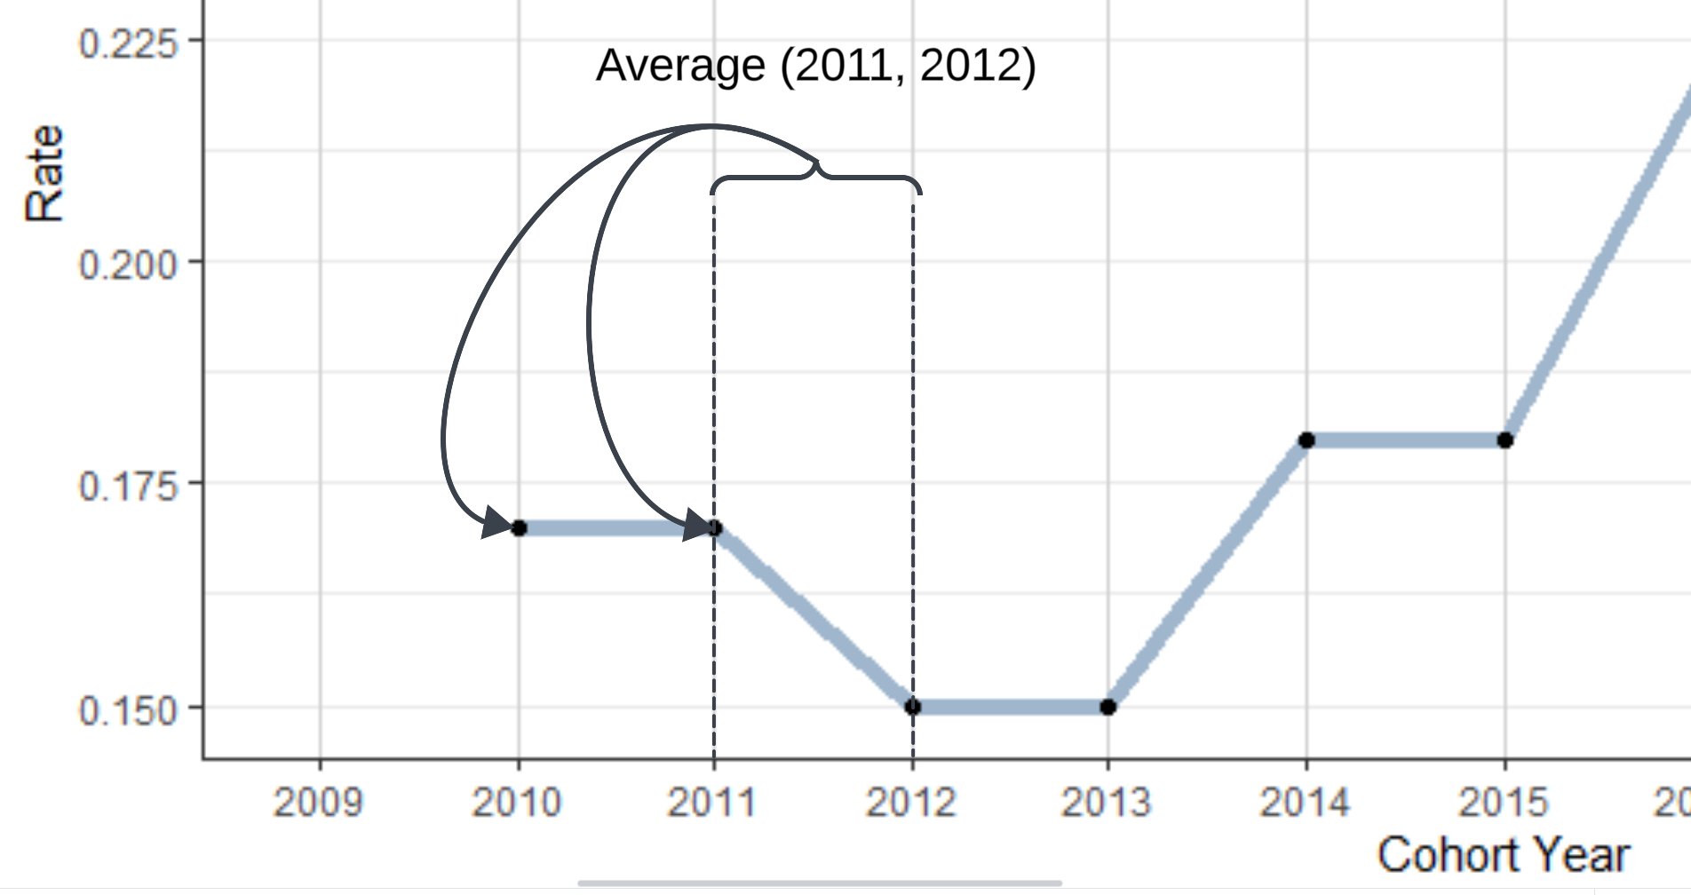
Similarly, for a three-year outlook we would:
- add 3 to 2010 (=2013)
- add three to 2011 (=2014)
- take the average of 2013 and 2014
- Assign that average to both 2010 and 2011.

4. Groupings

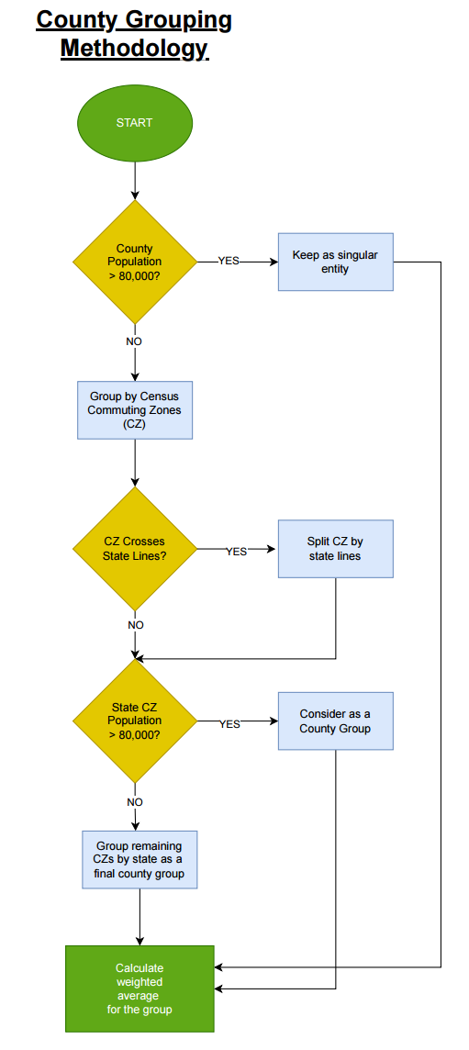
4.1 County Grouping

4.2 Estimation Grouping
